**Task 1: Theme Switcher using React Context api**

1. **Task Description**

A theme switcher that toggles from dark mode to light and vice versa, created using **global state management, Context Api**.

1. **Task Output Screenshot**

**Dark Mode**

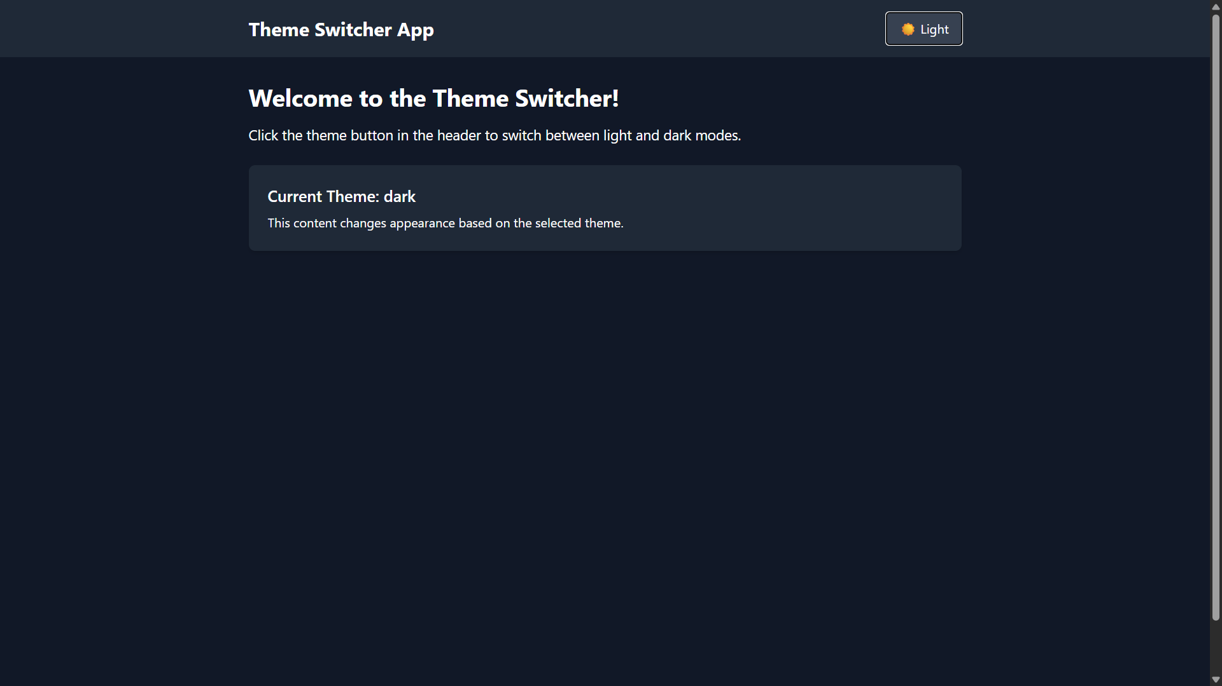

**Light Mode**

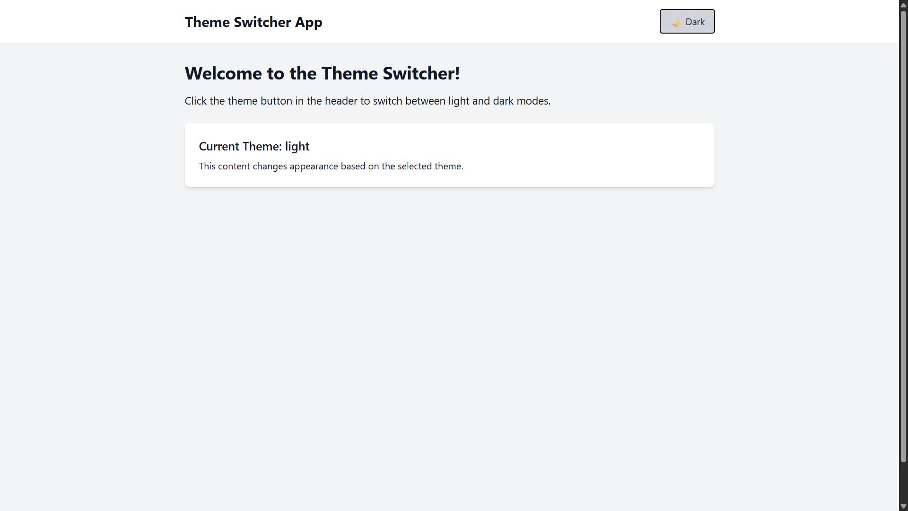

1. **File Structure and approach**

I structured the project in a clean and modular way to keep things maintainable and scalable:  
  
**1**. **Context/ThemeProvider.jsx**   
This file contains the centralized global state of the app using the Context API.   
It manages the current theme (light/dark) and provides a toggle function.   
I also created a custom hook (useTheme) for cleaner and more convenient access to the theme state inside components.  
  
**2. components/**

**Header.jsx:**  Contains the theme toggle button and demonstrates how the theme state can be consumed.

**Home.jsx:** Represents the main content of the app and applies theme-based styling with Tailwind classes.

**3. App.jsx**

The root component where I wrap the entire app with ThemeProvider, ensuring the theme state is available throughout the application.

**4. Tailwind css:** I used the tailwind css to style the respective mode/theme.